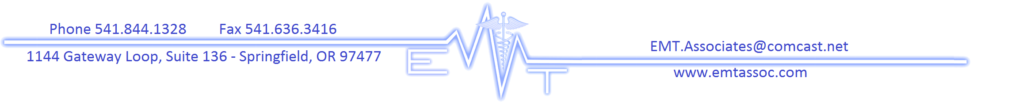

Become a CNA2 with

EMT Associates
  - www.cnawithemtassociates.com
541-844-1328
2021 Class Dates*
[* hours & fees subject to change depending upon new OSBN curriculum and COVID-19]

Classroom – 8am Start time Clinicals – 6:45am Start time

  - Jan 25-30 Feb 1-5
  - March 19-24 March 25-28
  - April 19-24 April 26-30
May 17-22 May 24-28
June 11-16 June 17-20
Rest of 2021 classes TBA

Program Requirements:
• Unencumbered Oregon CNA license; at least 75 hours of clinical time or work experience
• Go to Any Lab Test Now. Tell them you are applying to EMT Associates. Get a background check [including FACIS report] & drug screen within 30 days before class begins $95
• Copy of valid government issued picture ID and Health Insurance card
• Copy of American Heart BLS CPR card (we offer classes)
• Maroon Scrub top from EMT Associates; black or navy-blue scrub pants, watch with second sweep hand
•Vaccination Records: 2 step TB skin test [within past 12 months, Neg QuantiFERON or Neg chest x-ray also acceptable] Hep B [series], MMR, Tdap [within 10 years], Varicella, [vaccination record or blood titer acceptable], Flu [current season CDC]

Fees:

Tuition [includes $150 non-refundable registration, textbook, scrub top, 1 surgical $865*
mask daily for class & 1 face shield or protective goggles for clinicals]

Due to the COVID-19 pandemic, ALL STUDENTS are required to follow CDC and public health guidelines including social distancing, wearing a face covering, and participating in frequent hand-washing. Please bring a mouth/nose covering to class for your personal use. If you are unable to wear a mouth/nose cover, please contact the Training Center prior to arriving so that we can explore reasonable accommodations. Our training center has additional screening prior to class; per our COVID-19 policies.

